Solution to every third end-of-chapter problem
Basics of Engineering Economy, 2nd edition
Leland Blank and Anthony Tarquin

Chapter 11
Estimating Costs

11.1 Elements of first cost include equipment cost, delivery charges, installation cost,
insurance coverage, and training of personnel for equipment use.

11.4 Cost = 98.23(50,000) = $4,911,500

11.7 Cost = 1,350,000(1.70/0.93) = $2,467,742

11.10 Cost = 185,000(1634.9/1375.4) = $219,904

11.13 From Table, index value in 2003 = 6695; index value in 2012 = 9290
C_{t} = 30,000,000(9290/6695)
= $41,628,000

11.16 Cost₂₀₁₁ = Cost₂₀₀₂(1490.2/1104.2)
328 = Cost₂₀₀₂(1.3496)

Cost₂₀₀₂ = $243

11.19 31.39 = Rate₁₉₁₃(16,520.53/100)
Rate₁₉₁₃ = $0.19 per hour

11.22 C₂ = 9500(450/250)^{0.32}
= 9500(1.207)

= $11,466

11.25 If C₂ = 1.04 C₁ and Q₂/Q₁ = 0.50, the cost-capacity relation is

1.04C₁ = C₁ (Q₂/Q₁)^{x}

1.04 = (0.50)^{x}
log 1.04 = x log 0.50
x = -0.0566

11.28 Cost = 3750(2)^{0.89}(1520.6/1104.2) = $9570

11.31 1,320,000 = h(225,000)
h = 5.87

11.34 T₁₂ = T₁N^{s}

s = log 0.85/log 2
= -0.234

T₁₂ = (56)12^{-0.234}
= 31.3 months

11.37 Total direct labor hours = 3000 + 9000 + 5000
= 17,000 hours

Indirect cost/hour = 34,000/17,000
= $2.00

Allocation to Dept A = 3000(2.00)
= $6000

Allocation to Dept B = 9000(2.00)
= $18,000

Allocation to Dept C = 5000(2.00)
= $10,000

11.40 (a) Hand solution: Make alternative indirect cost computation

Dept | Rate  (1) | Usage  (2) | Annual cost  (3) = (1)(2)
M | $2.40 | 450,000 | $1.08 million
P | $0.50 | 850,000 | 425,000
Q | $25 | 4800 | 120,000
$/year |  |  | $1,625,000

Determine AW for make and buy alternatives.

AW_{make} = -3,000,000(A/P,12%,6) + 500,000(A/F,12%,6)

– 1,500,000 – 1,625,000
= -3,000,000(0.24323) + 500,000(0.12323) – 3,125,000
= $-3,793,075

AW_{buy} = -4,500,000 – 200,000(A/G,12%,6)
= -4,500,000 – 200,000(2.1720)
= $-4,934,400

Select make alternative.

(b) Spreadsheet solution: Select to make inhouse.

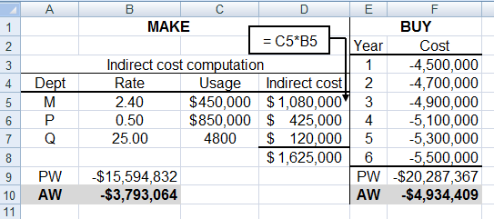

11.43 Compare last year’s allocation based on flight traffic with this year’s based on
baggage traffic. Significant change took place.
 | Last year;  flight basis | This year;  baggage basis | Percent  change
DFW | $330,000 | $343,620 | + 4.1%
YYZ | 187,500 | 218,371 | +16.5
MEX | 150,000 | 105,363 | – 29.7

11.46 The answer is (c)

11.49 C₂ = 22,000(300/200)^{0.64} = $28,518

Answer is (b)

11.52 C_{T} = 2.45(390,000) = $955,500

Answer is (a)

11.55 3,000,000 = 550,000(100,000/6000)^{x}
5.4545 = (16.67)^{x}
log 5.4545 = xlog16.67
x = 0.60

Answer is (d)

11.58 Allocation = (900 + 1300)(2000) = $4.4 million
Percent allocated = 4.4/8.0 million = 55%

Answer is (c)

